What caused the First World War?

World War I commenced in 1914 and ended in 1918.  It began as a European conflict but quickly escalated into an international one which included some thirty-two (32) countries.  Millions of civilians were killed in this war coupled with the many soldiers who lost their lives.   Prior to the start of the Second World War in 1939, this war was referred to as simply the World War as well as the Great War.

In 1914, the world was dominated by Europe when it came to power and prestige.  In Europe, Germany had the strongest military and she was the most industrialised.  However, prior to 1914, Britain had held the position as the most powerful.  Due to her drop in position, she (Britain) became afraid for her security as she is an island and can therefore be locked through a sea blockade by Germany.  This would restrain her from managing her trading routes which she had a monopoly in.   
  
Following both Germany and Britain however is the Hapsburg Empire followed by Russia which was the most backward country in Europe as she was very reserved and only interested in internal affairs.  She was not very industrialised.    
  
Although the world was dominated by Europe in terms of power and prestige, the most powerful country was not a European one.  The most powerful country was in fact USA.  She had vast amounts of coal mines as well as iron.  This exceeded the amounts produced by Britain and Germany combined.  This allowed her to strengthen her armaments and to trade.  She traded a lot with Japan which to some extent allowed Japan to rise up as a powerful and modern country.    
  
The world powers in 1914 were (in order):  
 1 – USA

2 - Germany  
 3 - Britain  
 4 - Japan  
 5 - Hapsburg Empire  
 6 - Russia

**The Causes**

1. **The Alliance System -** By 1914, the six (6) most powerful European countries divided themselves into two (2) arm camps known as the Alliance System.  The two arm camps or the two alliances were:  
    - The Triple Alliance (Germany, Austria-Hungary, Italy)[formed in 1882]  
    - The Triple Entente (Britain, France, Russia)[formed in 1907]

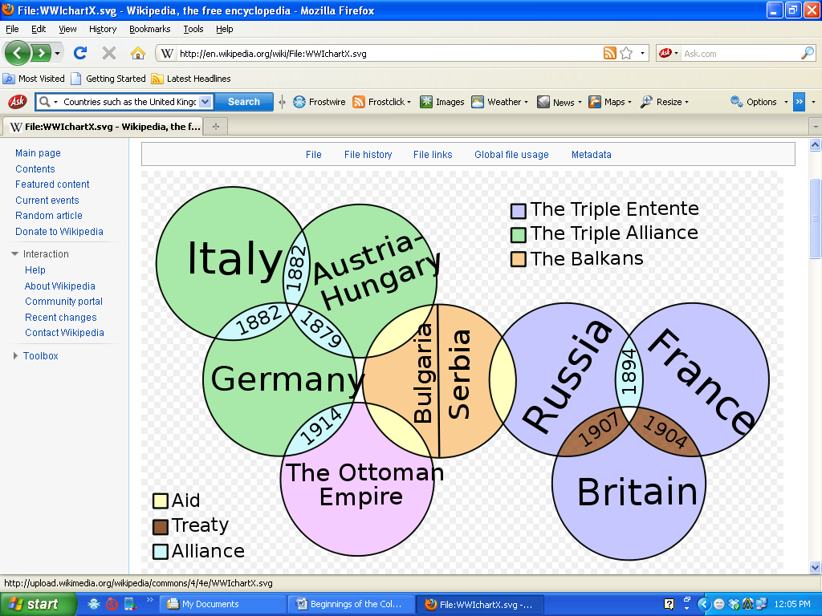

The Alliances

There were a number of smaller alliances between various countries such as the Treaty of London (1839) between Britain and Belgium which dealt with Belgian neutrality in war, the Dual Alliance (1879) between Germany and Austria which changed into the Triple Alliance when Italy joined in 1982 and the Franco – Russian Alliance in 1894 as well as the Entente Cordiale in 1904 between Britain and France.

1. **Naval Challenge between Britain and Germany** – Britain, a European island, had a motive for having a strong navy.  Germany on the other hand was a continental nation with little access to the sea and therefore has no need for a strong, extensive navy.  In 1900, Germany began to crate her navy with the intention of making it as strong as Britain who had the strongest in the world.  This would obviously conjure up thoughts on Britain’s part as to what Germany’s motive for this was.  Was it for status?  Was it for rivalry?  Or was it to claim Britain’s position and her monopoly in trade?  They (Britain) were not certain and in a bid to maintain their status and protect themselves, they began strengthening their already powerful navy.  In 1906, Britain launched their HMS Dreadnought (a battleship).  Germany later launched her version in an effort to topple Britain’s.  By 1914, Britain had a total of twenty-nine (29) Dreadnoughts while Germany had seventeen (17).

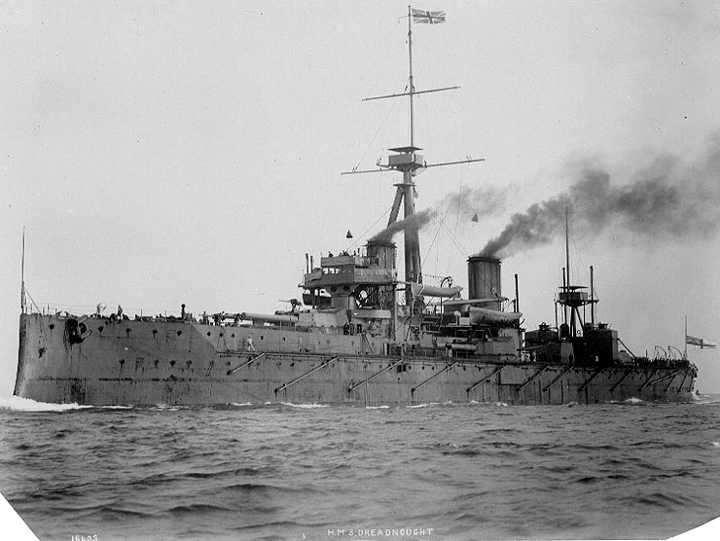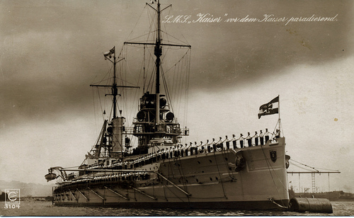

**QUESTION:** Can you tell why Germany was challenging Britain from the looks for the two warships?

(The German Warship on the Right is before Germany started making Dreadnoughts of her own.)

1. **French disgust towards Germany** – The French hated Germany for three (3) major reasons.  These were:
2. Germany had annexed a part of France in 1870 called Alsace – Lorraine. These regions were very industrialised and valuable to France.
3. The fact that Germany was declared a unified nation at the Hall of Mirrors in the Palace of Versailles in France.
4. And most of all, Germany defeated France in the Franco – Prussian War of 1870. This war made Germany unified.
5. **Encirclement theory** – Two major nations bordered Germany (France and Russia).  Both of these countries were allied to Britain which made Germany feel as if she was being plotted against by being virtually “locked in” by two allies of her number one enemy – Britain.  She subsequently accused Britain of this “encirclement theory”.

1. **Imperialism**– Britain and France accrued immense wealth in the late 19th century through imperialism.  Imperialism allowed them the chance to control trade in foreign markets and territories.  In fact, Britain was a “pro” at this as she had the monopoly in trade across the world.  This led other countries to become jealous of her empire and this fueled their imperialistic actions.  Germany, Austria-Hungary, Italy, and Russia all hoped build up their empires to the extent of Britain and France.  They felt this would be a status symbol (especially Germany) and it would bring economic benefits to them.  Commercial interests aided in the substantial Anglo-German rivalry during the scramble for Africa.  One of the well known colonial rivalries dealt with the Moroccan Crisis of 1905 as well as 1911.
2. **Moroccan Crisis of 1905** – The Entente Cordiale was signed in 1904 between Britain and France whereby France pledged to respect Britain’s position in Egypt and in return, Britain would give France control over Morocco.  The German Kaiser wanted to test the strength of this agreement.  He felt it was weak as the two (2) were recently involved in their own colonial rivalries in Africa, Asia and the Pacific.  The Kaiser got into contact with the Moroccan Sultan and told him that he would aid him in maintaining his country’s independence.  Russia, Italy as well as Spain supported the French in their control over Morocco at the Algeciras Conference which ended the crisis.  This was a huge humiliation for Germany as her own Triple Alliance ally (Italy) did not support her move.  Germany backed off concluding that the agreement was in fact strong but it did lead to friction as almost all countries now felt even more threatened by Germany and they saw her to be the one “picking trouble”.
3. **Anglo – Russian agreement of 1907** – Due to the Russo – Japanese war in 1904 – 1905, Russia was seen to be a threat by Germany even though she was totally humiliated by the Japanese.  Britain saw her to be a threat because she was not a well developed country and was the most backward country as she was not interested in international affairs.  Her industry was weak and so for her to become involved in such a war with a much more developed and modern country was a big strive.  In 1907, the two became allies as they both felt they needed each other.  Britain needed her to “keep an eye” on Germany for her and Russia needed Britain to help her grow.
4. **Bosnian Crisis of 1908** – Nestled within Turkey is a land known as Bosnia.  It was occupied by both Slavs and Serbs.  It had a population of over 3 million.  In 1908, their crisis began when Austria took control.  The Slavs and Serbs appealed for help but none was rendered.  Russia was an ally of Serbia but she was not in a good position to render help as she was just defeated in war.  Britain and France were too afraid of what the strongest army in Europe – Germany – might do as she was allies with Austria and as a result, they did not intervene.

Two (2) major effects occurred after this crisis.  These were:

* 1. It strengthened opposition between the Austrians and the Serbians
  2. It led Russia to take measures to strengthen and develop its military

1. **Moroccan Crisis of 1911** – In 1911, another crisis over Morocco emerged.  It occurred at Agadir in Morocco where Germany felt it was unfair that France got Morocco and she did not get anything.  As a result, she sent a gunboat called the Panther to a bay in Agadir.  This left the French in a position whereby they felt threatened that Germany would annex Morocco just like she annexed Alsace – Lorraine in 1871.  This also made Britain feel threatened as she felt that if in fact Germany annexed Morocco, it could harm her as Germany might end up challenging her monopoly in trade.  In the end, the Germans however removed the gunboat in exchange for two (2) stripes of land in French Congo.  This however raised more conceptions that Germany would always be a threat as she came back again into Morocco.

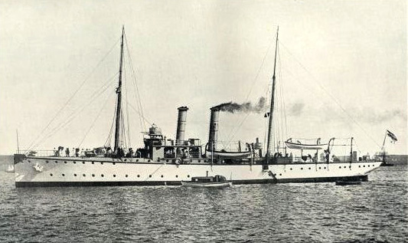

The German Gunboat, the Panther

1. **The Plans for War –** Each of the European Powers had their own plans for war. These plans outlined precisely what they would do in the event of war, or how they would start a war.

* + Germany’s plan was called the Schlieffen Plan where the German army would march though Belgium into France and defeat them then march back through Belgium back into Germany then into Russia.
  + France’s plan was called Plan XVII where some soldiers would invade Alsace – Lorraine and capture it while others would invade Germany from the Ardennes forest and force Germany to surrender.

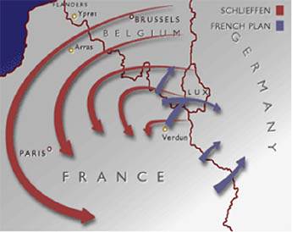

Schlieffen Plan into France & French Plan XVII

* Britain formed the British Expeditionary Force (BEF) with some 150,000 highly trained and well equipped soldiers who would fly to France in the event of a war.
* Russia’s plan was called Plan G where they assumed the Germany would launch a full scale war on them however the size of the Russian Army (largest army in Europe) would scare the Germans away.

1. **The Balkan Crisis** – This region was a rather unstable one which contained a number of different nationalities.  It was ruled by Turkey for quite some time however in 1908, Turkish power began to decline. Conflict was always occurring because the people wanted their independence. Russia as well as well as Austria bordered the Balkan region and both nations desired to take control of the region.  After the 1908 Bosnian Crisis, Russia began to strengthen its military.  She was confident not to back down again in the future.  Between 1912 and 1913, there were many little wars in the Balkans.  Serbia, Greece, Bulgaria and Montenegro joined forces and created the Balkan League and in October 1912 they successfully attacked the Turks (First Balkan War) and drove them out resulting in a Peace Settlement were Serbia gained most of the territory. In the region, Serbia was a powerful army and they were allied with Russia which alarmed Austria. Austria was jealous and always desired to wage war on Serbia to crush them but needed a legitimate reason (which came after the Murders in Sarajevo).

The Balkan League was short lived though and a Second Balkan War emerged as Bulgaria quarreled with Serbia and Greece and later attacked them but was defeated.

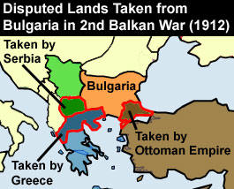

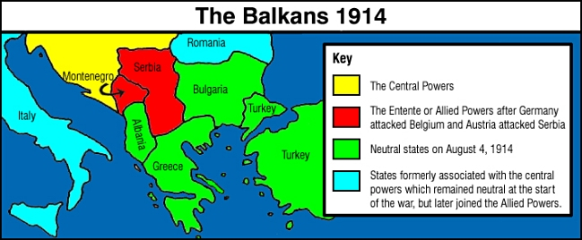

The Balkan Countries and their Allies

1. **Murders in Sarajevo** – On Sunday 28th June, 1914, the Austrian heir to the throne, Franz Ferdinand was on a royal tour in Sarajevo, Bosnia with his wife, Sophie.  As a result of the 1908 takeover of Bosnia by Austria, there was a lot of hostility, resentment and anger on the part of the Bosnians towards the Austrians.  There was always the desire for the Bosnians to break off from Austrian rule and form their own state called Yugoslavia.  One group called the Black Hand Gang emerged whose sole aim was to end Austrian rule of Bosnia by assassinating the heir to the Austrian rule while one the royal tour.

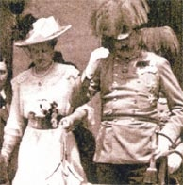

The Archduke Franz Ferdinand and

his wife Sophie

At the start of the royal tour, a grenade was thrown by a member of the group called Cabriolvic.  After he threw the grenade he swallowed poison and jumped into the nearby river.  Total chaos emerged after.  The royals were not hurt as it was not thrown at their car but patrons were injured.  Ferdinand was taken to the Town Hall where he demanded to go see the injured in the hospital.  As it was an order, it was to be fulfilled.  A new route had to be taken to avoid the chaos.  The new route was not properly explained to the driver.  The royals this time were oddly and foolishly not accompanied or escorted by police.  The Black Hand Gang assumed they had killed the royals and all except one member, Princip fled to celebrate.  Soon news broke out that the royals were in fact alive and not hurt which ultimately got Princip upset.  He walked across to Schillers Café and waited outside basking in anger then all of a sudden he saw the royal car pull into the street.  The driver took the wrong turn but Princip realized it was his chance to murder the heir.  He took out his revolver and fired two shots.  One hit Sophie in her stomach and the other hit Ferdinand in the neck.  Both died in a matter of minutes.  Princip was arrested and sent to prison.

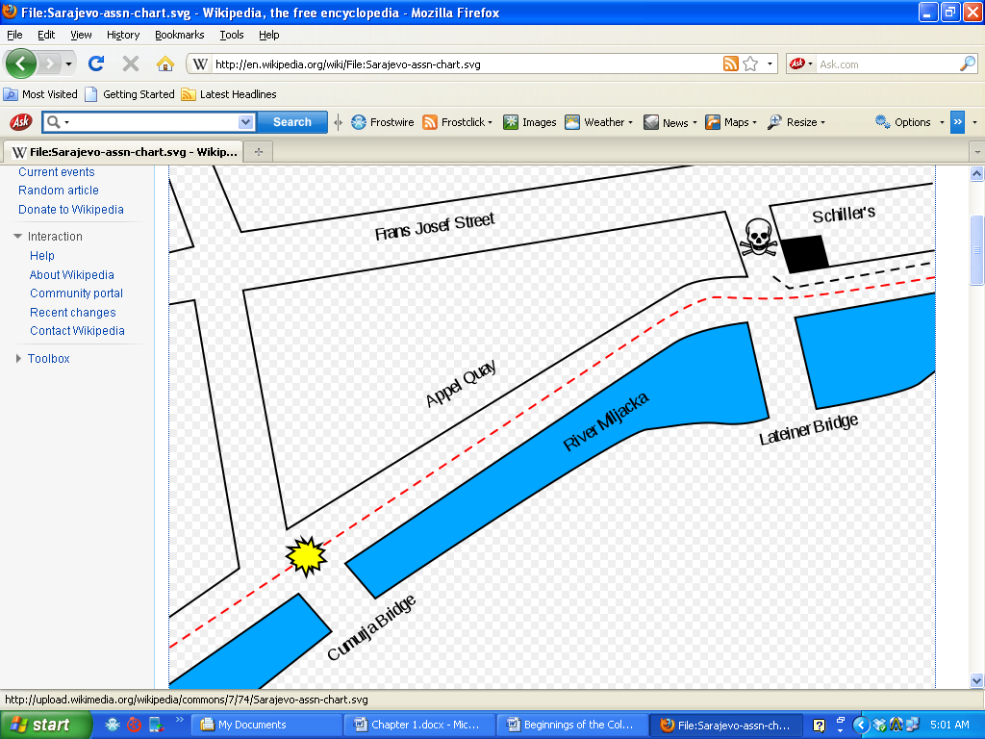

Illustration: Routes

- (Dashed Red line – Route taken to go to the Town Hall) - Yellow – Grenade thrown) - (Dashed Black line – Route taken to go to the hospital) - (Skull – Assassination site)

What was significant about this though?  Austria finally got her reason to wage war on Serbia.  She sent a 10 – point Ultimatum to Serbia which was grossly unfair, she however felt Serbia would not accept and she could attack.  Serbia however, surprisingly accepted nine (9) of the terms and seek some more time to deliberate on the last remaining term.  Austria was surprised but her aim was to attack and so on the 28th July, 1914 she waged war.  Continuous war broke out as the allies joined in and then the allies of the allies etc.  The Murders in Sarajevo is therefore seen to be the “last straw” before war finally came.

**How did the war roll out?**

***23rd July*** – 10 Point Ultimatum

***28th July*** – Austria declared war on Serbia

***29th July*** – Russia mobilised her troops to support Serbia

***30th July*** – The Kaiser (Germany) warned the Tsar (Russia) to stop mobilising

***31st July*** – Germany gave Russia a threatening ultimatum

***1st August*** – Germany wages war on Russia and moves towards Belgium & France

***3rd August*** – Germany declares war on France with some German troops in Belgium and Britain orders her to leave

***4th August*** – Britain declares war on Germany

***6th August*** – Austria declares war on Russia

**Which was the more important in Causing World War One?**

**Effects of the Alliances**

1.   The Triple Alliance frightened France, who saw it as part of a German plan to take over Europe

2.   The Triple Entente alarmed Germany, which felt itself surrounded by the France-Russia alliance.

3.   **Note that it is arguable that Alliances were the main cause of the war.** The countries of Europe thought that the alliance system would act as a deterrent to war; there is an argument that in fact it tied them together so that in 1914 when one country went to war, the others **HAD** to follow.  

**Results/importance of the Arms Race**

1.   The HUGE German Army made other countries think that Germany wanted to rule the world.

2.   The Russian army was growing the fastest, and German generals were worried that, in a few years time, they would not be able to defeat Russia - in 1912, the German general Moltke said: 'War the sooner the better'.

3.   **Note that it is arguable that the Arms Race was the main cause of the war.** There is an argument that the fact that they HAD huge armies made it easier for governments to suggest a military solution to foreign policy problems - if you have a huge army, you might as well use it.

**Effects of the 1905 Moroccan Crisis**

1.   The French were furious with Germany, and the British saw it as yet another attempt by Germany to build an Empire, so in 1907, France, Britain and Russia made the Triple Entente.

2.   At Algericas, Germany had to promise to stay out of Morocco = felt humiliated/ annoyed.

3.   **Note that it is arguable that the 1905 Moroccan Crisis was the main cause of the war.** Algericas convinced Germany that the other countries were 'ganging up' on it - from this moment, Germany started getting ready for war.

**Effects of the 1911 Agadir Crisis (Second Moroccan Crisis)**

1.   France and Britain were furious because Germany had broken its promises at Algericas (in Britain, Lloyd George attacked Germany and promised support for France in his 'Mansion House speech').

2.   Nov 1911: Treaty of Berlin (where Germany was forced to remove the gunship and Morocco became a French colony) made Germany angry: Wilhelm said: 'these events have shown the German people where its enemy is'.

3.   **Note that it is arguable that the Agadir Crisis was the main cause of the war.** One historian has written: 'the Kaiser was determined not to be the loser in the next crisis'.

**Results of the Bosnian Crisis**

**Note that it is arguable the Bosnian Crisis was the main cause of the war.**

1.   Serbia was angry because Bosnia was full of Serbs - this caused the assassination at Sarajevo.

2.   Kaiser Wilhelm was proud that he had helped Austria 'in shining armour' - so he did so after Sarajevo he gave Austria a 'blank cheque', which led to the slide to war in 1914.

3.   Russia was angry at having to back down and vowed not to do so again - this caused Nicholas's disastrous decision to mobilise for war in 1914.

**Results of the Sarajevo Crisis**

1.   **Note that it is arguable that Sarajevo caused the war:** The assassination provoked Austria to go to war with Serbia, which led to the slide to the First World War.

2.  **Note that it is arguable that Sarajevo did NOT cause the war:**

* The assassination caused horror, but not an international crisis (the Kaiser went on holiday).
* It was **Austria** which provoked the international crisis by sending Serbia an ultimatum on 23 July 1914 - it was THIS which started the sequence of events leading to the outbreak of war.

**Significance of the Schlieffen Plan**

**Note that it is arguable the Schlieffen Plan was the main cause of the war.**

1.   It was a plan of attack: unlike other countries - which could mobilise without attacking - when Germany wanted to mobilise, **Germany had to attack France**.

2.   It **did not** plan for a situation where Germany was at war with Russia, but not with France.   In 1914, Germany was forced to invent a reason to declare war on France (3 August 1914).

3.   The Schlieffen Plan went through Belgium …this **brought Britain into the war**.